PFC - Workshop 5B

1. Coin tossing
Design and code a program named coinToss.c that
- prompts the user for the number of coin tosses
- accepts the number of tosses
- simulates the requested number of tosses
- calculates the percentage of head results for all of the tosses
You may assume that the user will enter the input without error.
The output from your program looks something like
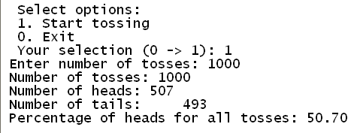

2. Input & reverse a string

Write a program using getchar() function only to read the character string from the keyboard until ‘.’ is terminated, then reverse the string and display result on the screen.
The output from your program looks something like
